Experiment 01

1. To develop a website and host it on your local machine on a VM
2. Give name to EC2 instance

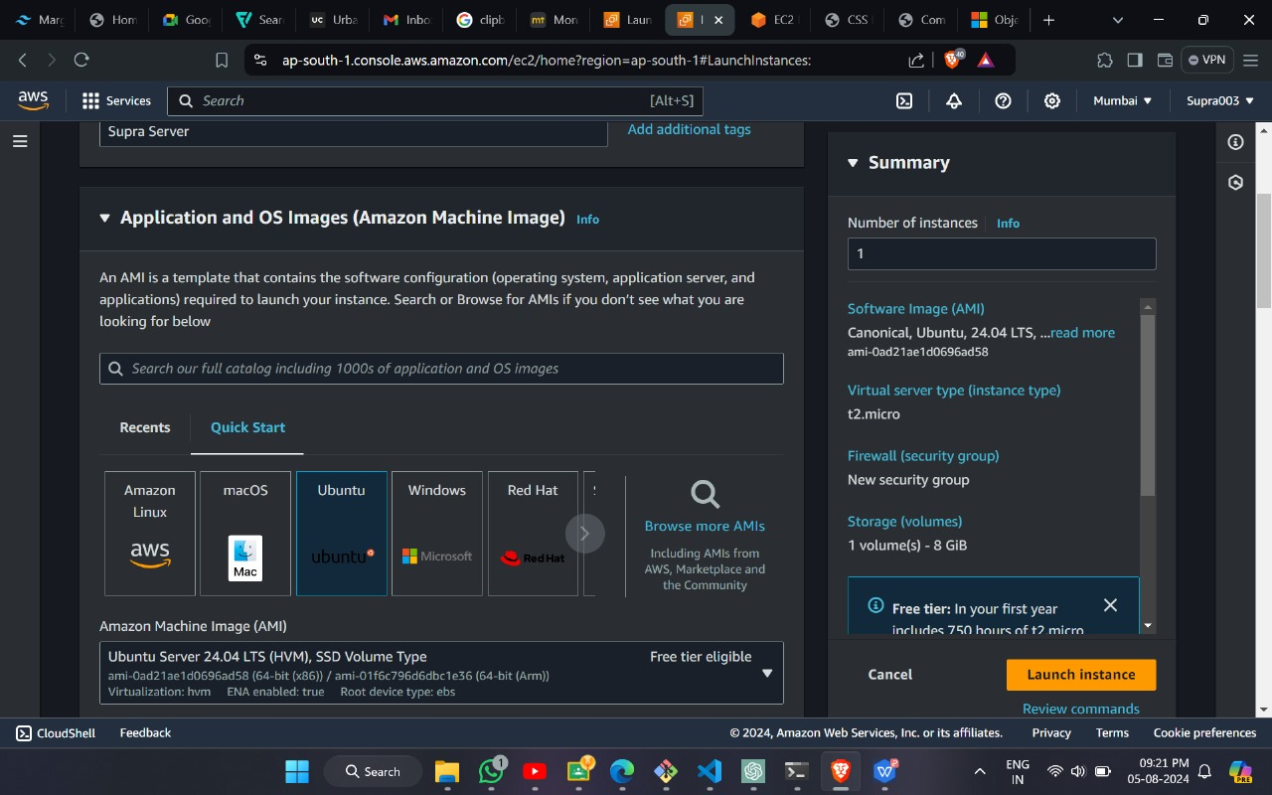

1. Create a key-pair login.

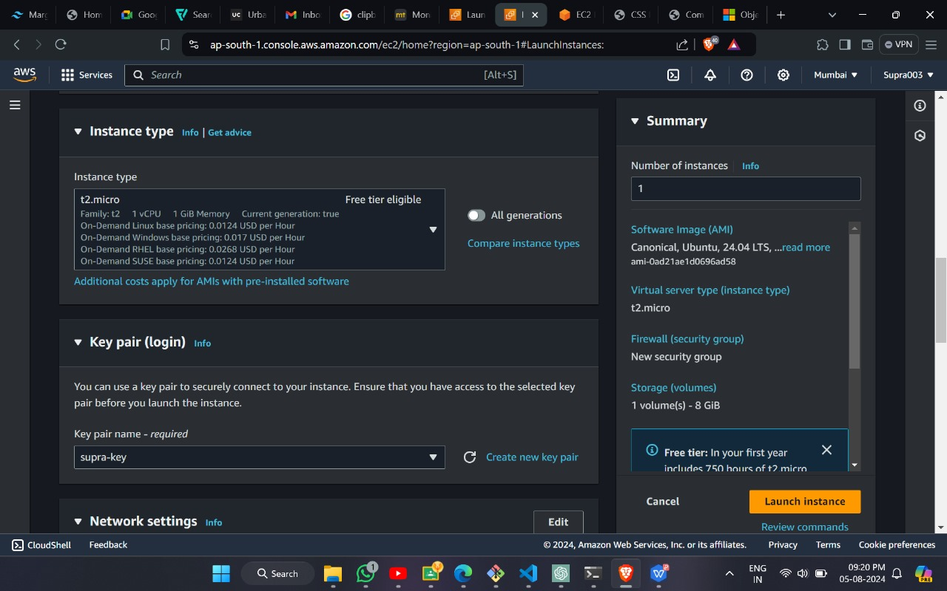

1. Edit network settings. And Launch Instance.

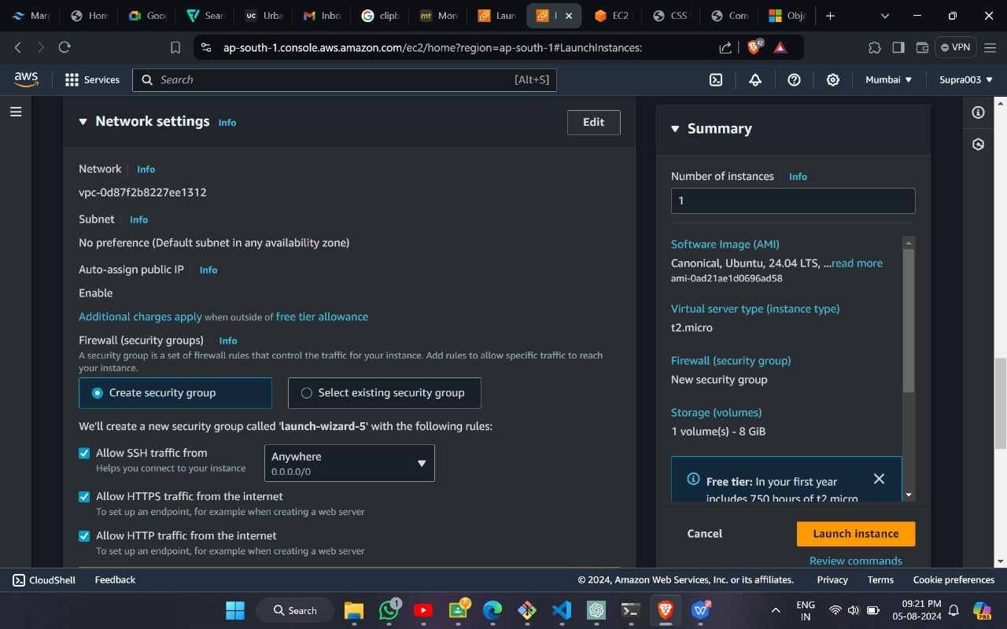

1. Instance successfully lanunched.

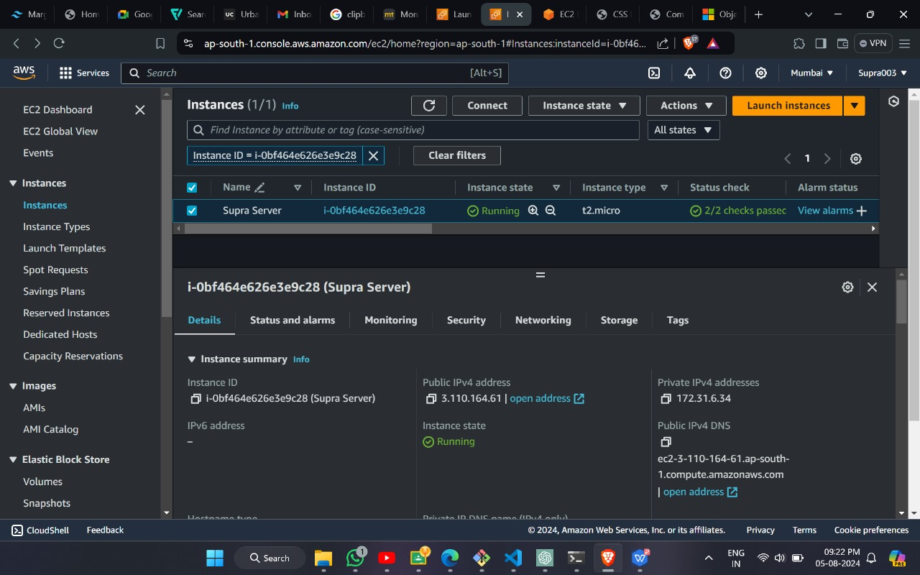

1. Create a virtual environment with key pair permission.

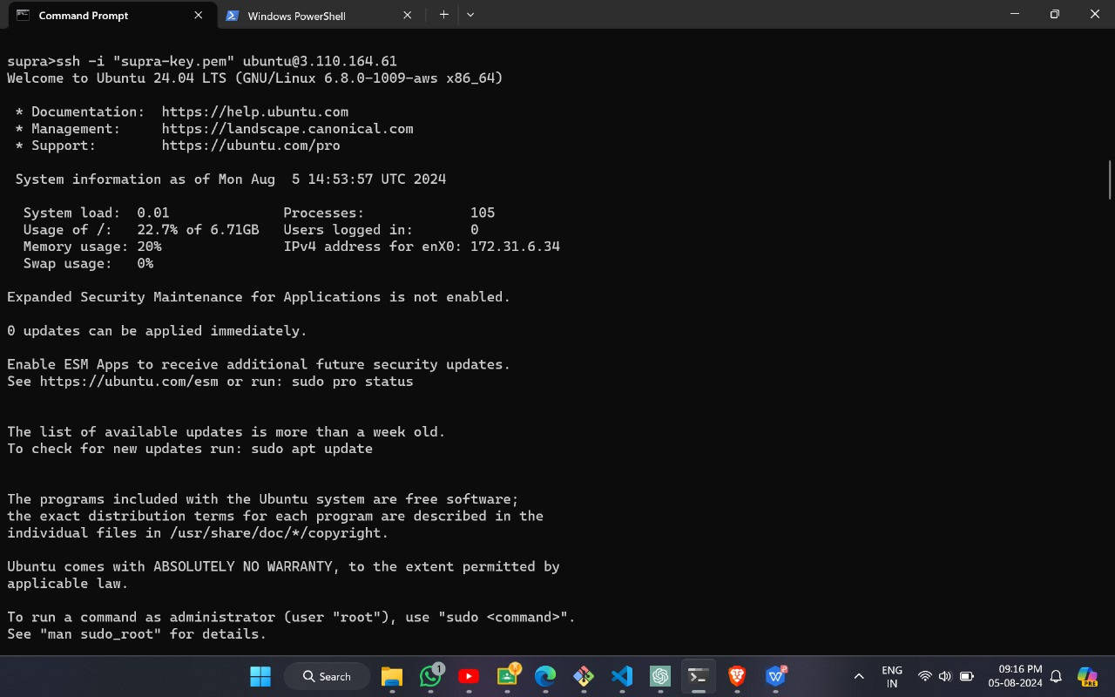

1. Install apache on virtual machine.

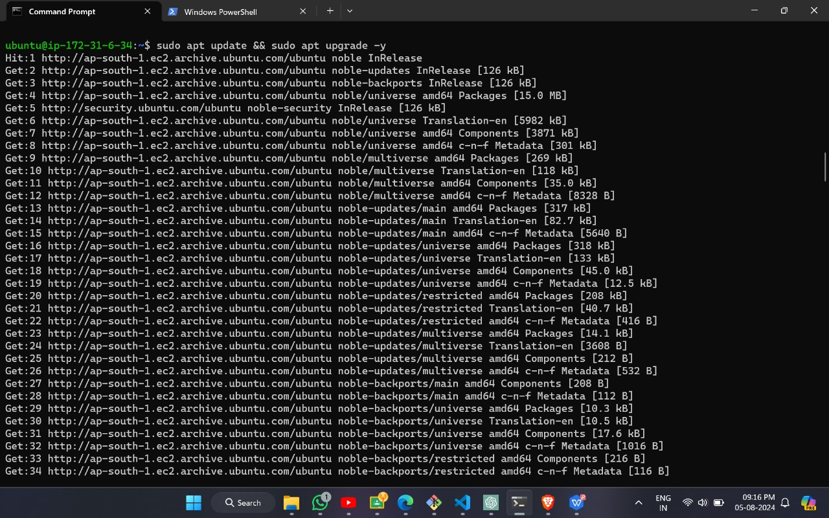

1. Update and upgrade it.

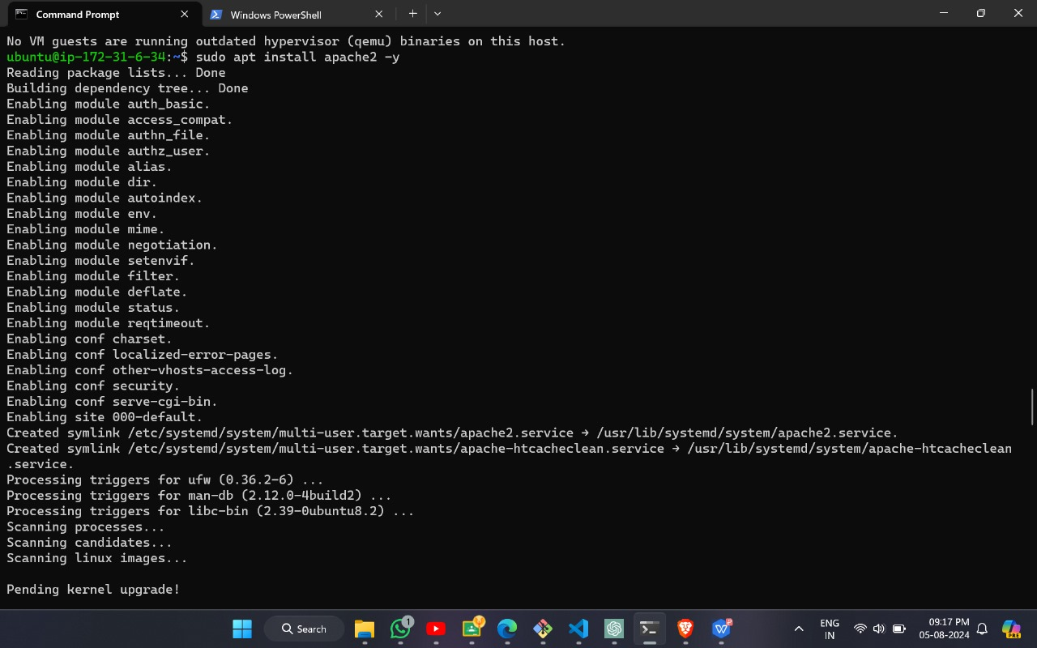

1. Start the apche server.

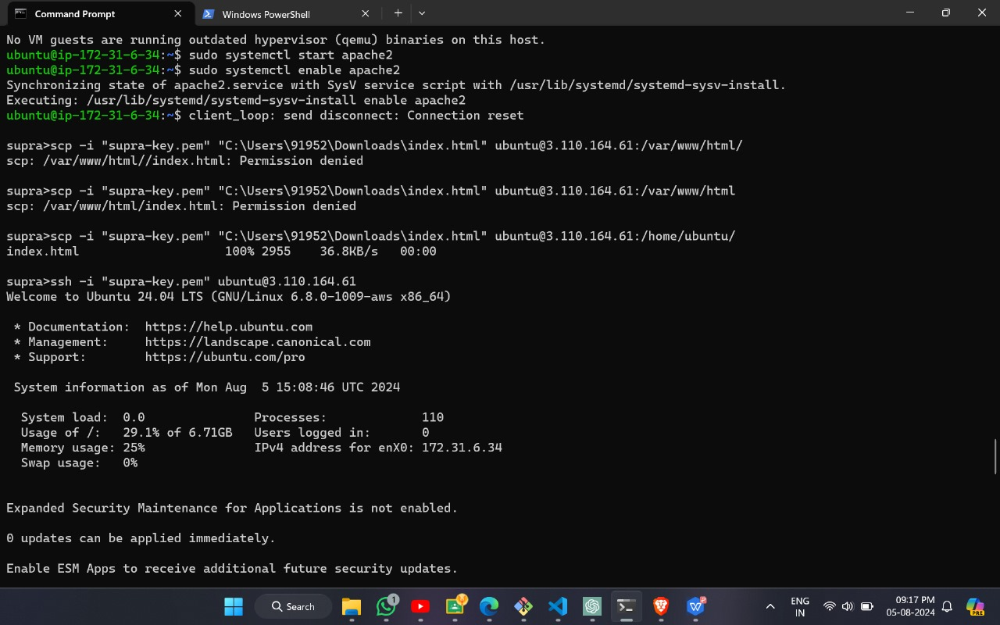

1. Give file location to be executed.

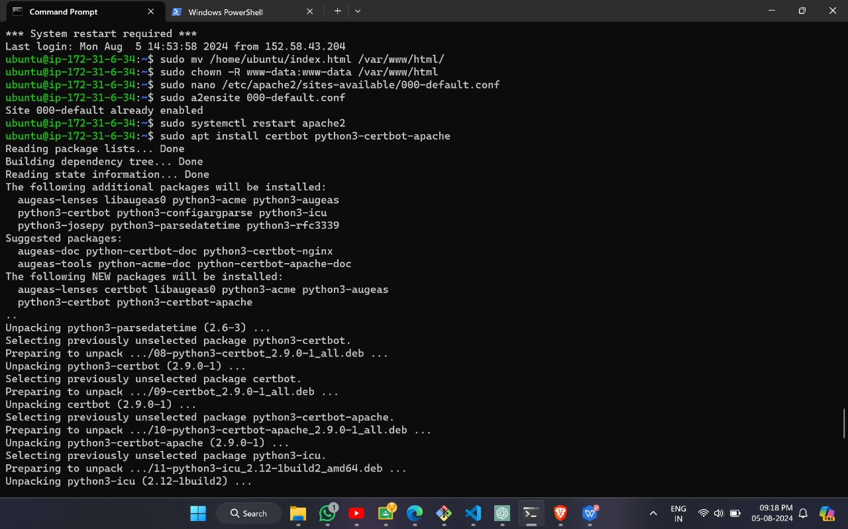

1. Output of the code on local machine.

